**ADONAI FARMS: TECH THAT PLANS THE FUTURE**

ABSTRACT

Adonai Farms, in Sagana, Kirinyaga County, experiences significant agricultural planning challenges due to the absence of a localized, precise weather forecasting system. This project addresses this issue by developing and implementing a comprehensive weather system tailored to the farm's specific needs. The system integrates an on-site weather station with external data sources, utilizing statistical analysis and machine learning algorithms to generate accurate, location-specific weather predictions. A user-friendly web application, enabling improved decision-making regarding planting, irrigation, pest control, and harvesting. The expected outcomes include enhanced crop yields, reduced resource waste, and increased farm resilience to unpredictable weather patterns, ultimately contributing to improved profitability and sustainable agricultural practices.

A) INTRODUCTION

1.1Background

Adonai farms’ main area of specialization is in horticulture and growing fruits. It has 3 permanent employees that do the labor and when the work load is more than they usually work with, they usually hire outside labor bringing the total number of employees to around 6. It is located in Sagana, Kirinyaga county which is most suitable for the growth of crops like kales, spinach and peas and fruits like oranges and grapes which are their main focus. They usually experience losses because of unpredictable weather patterns, e.g last year during the short rains season they ended up getting long rains which ended up destroying some of they produce as they had not planned for such a situation beforehand. The weather web based that I will create for them will assist them in getting to know the weather patterns accordingly so that they can be able to plan and hence avoid losses

**1.2 Problem Statement**

Adonai Farms faces significant challenges in optimizing agricultural planning and operations due to the lack of accurate and timely weather information tailored to their specific location and crop needs. This results in:

a) Increased vulnerability to unpredictable weather events: Such as heavy rainfall, frost, or drought, causing crop damage and financial losses.

b) Inefficient resource allocation: Due to the inability to accurately predict water needs and potential risks.

**1.3 Proposed solution**

The proposed solutions that are to tackle the above problems are as follows;

1. Real-time Alerts and Proactive Measures; I will implement an alert system within your JavaScript application that triggers notifications.
2. Risk-Based Resource Planning: Use the weather prediction model to assess potential risks (e.g., flood risk, drought risk).Develop contingency plans and allocate resources accordingly. Provide information about the possibility of needing to use extra resources

**1.4Research Objectives**:

i) General Objective

To develop and implement a comprehensive, localized weather system for Adonai Farms , that provides accurate and timely weather information to enhance agricultural planning, optimize resource utilization, and improve overall farm productivity and resilience.

ii)Specific Objectives

1. Create a User-Friendly Weather Information Delivery System: I will develop a web based application to display real-time weather data, forecasts, and alerts.
2. Evaluate and Improve the Weather System:
3. Conduct regular evaluations of the system's accuracy and effectiveness-

Gather feedback from farm personnel on the system's usability and usefulness.

Implement necessary improvements and updates to the system based on evaluation results and user feedback.

1. Provide Training and Support:

Conduct training sessions for farm personnel on how to use the weather system and interpret the data.

Provide ongoing technical support for the system's operation and maintenance.

**1.5Significance of the study**

Weather prediction is not easy and when it comes down to it mistakes may be bound and most of the time it inconveniences people living in certain geographical areas, this is the main significance

Other significances include;

1. Providing Adonai farm with accurate weather prediction

2. To be able to understand weather patterns, trends and anomalies better.

3. For accurate weather prediction.

**1.6Justification**

The development of a localized weather system for Adonai Farms is justified by several critical factors:

1. **Climate Change Impacts**:

Kirinyaga county, like many agricultural regions, is experiencing increased weather variability due to climate change. Erratic rainfall, temperature fluctuations, and extreme weather events pose significant risks to crop production. A tailored weather system will enable the farm to adapt to these changes and mitigate potential losses.

1. **Need for Precision Agriculture**:

Modern agriculture demands precision to maximize yields and minimize resource waste. Generic regional weather forecasts are insufficient for making informed, localized decisions. An on-site weather system provides the necessary granularity for optimizing irrigation, fertilization, and other farm operations.

1. **Economic Benefits:**

Improved weather forecasting will lead to more efficient resource utilization, reduced crop losses, and increased yields. This translates to higher profitability for Adonai Farms, contributing to the economic sustainability of the operation.

d)**Food Security**:

Enhancing agricultural productivity is crucial for ensuring food security, both locally and regionally. By improving farm efficiency and resilience, this project contributes to a more stable and reliable food supply.

1. **Technological Advancement**:

Implementing a modern weather system demonstrates the application of technology in agriculture, promoting innovation and encouraging the adoption of data-driven practices. This serves as a model for other farms in the region.

1. **Risk Reduction**:

By having accurate localized weather predictions, the farm can reduce the risks associated with planting, spraying, and harvesting. This will lead to less wasted resources, and higher profit margins.

g) Resource Management:

Water is a limited resource. Accurate weather predictions will allow for better water management, and less water waste.

h) Data Driven Decisions:

The system will provide valuable data that can be used to make data driven decisions. This will improve all aspects of the farm.

**1.7 Scope of work**

The project involves the creation of software that will help the employees at Adonia Farm to get up to date weather forecasting so as to be able to understand the patterns, trends and anomalies in the weather throughout different weather season in order to plan adequately.

Project Requirements

Hardware Requirements

1. A personal computer with following minimum specifications

a) 4GB RAM

b) 2.4 GHz processing speed

c) 256 SSD disk space

2. WIFI adapter

Software Requirements

1. Operating System: The system should be compatible with Windows, macOS, and Linux operating systems.

3. Development Tools; Integrated Development Environments (IDEs) such as Visual studio code for programming the software to be used.

4. Version Control System; Git for source code version control.

5. Collaborative Design Platforms: Figma or Adobe XD for interface prototyping.

6.Browser Compatibility: Support for commonly used browsers like Chrome, Firefox, Safari, and Edge.

B**: SOFTWARE DEVELOPMENT METHODOLOGY**

2.1**INTRODUCTION**

This chapter mainly focuses on the analytical and design processes which are conducted to develop the weather system web application. It outlines the methods and ways that are used to gather requirements needed, analyze the system and then design it to fit the users’ i.e Adonai Farms.

2.**2Research Design**

The best research design system to be used here is the lean six methodology which is centered around rapid planning, self-organization and short delivery times. Its flexible. Fast and aims for continuous improvements in quality. The steps involved include;

**1.Defining the Problem (Define Phase):**

-Clearly define the problem: "Adonai Farms experiences inconsistent crop yields and increased operational costs due to unpredictable weather patterns."

-Identify stakeholders: Adonai Farms management, farm workers, customers.

-Establish project goals: Improve yield predictability, reduce weather-related losses, optimize resource allocation.

**2.Measuring Current Performance (Measure Phase**):

-Collect baseline data on weather patterns, crop yields, resource usage, and financial losses.

-Analyze historical weather data and identify key variables (temperature, rainfall, humidity, etc.).

-Measure the accuracy of current weather forecasting methods (if any).

-Quantify the impact of weather variability on farm operations.

**3.Analyzing the Data (Analyze Phase**):

-Use statistical tools to identify root causes of weather-related problems.

-Analyze the relationship between weather patterns and crop yields.

-Identify inefficiencies in resource allocation due to weather uncertainty.

-Determine the accuracy and precision of the javascript weather prediction model.

**4.Improving the Process (Improve Phase):**

-Implement the JavaScript weather prediction model.

-Develop standardized operating procedures for using weather forecasts in farm management.

-Optimize resource allocation based on predicted weather conditions.

-Implement feedback mechanisms to continuously improve the model's accuracy.

-Create a user friendly interface for the workers at Adonai Farms.

**5.Controlling the Process (Control Phase):**

-Establish monitoring systems to track weather forecast accuracy and crop yields.

-Develop control charts to identify deviations from expected performance.

-Implement corrective actions to address any issues.

-Document the improved processes and train farm workers on their use.

-Create a system that automatically updates the weather forecast, and that sends alerts to the farm workers when extreme weather is predicted.

**Benefits of Using Lean Six Sigma:**

1.Data-Driven Decisions: Lean Six Sigma emphasizes using data to make informed decisions, reducing reliance on guesswork.

2.Process Optimization: It helps identify and eliminate waste, leading to more efficient farm operations.

3.Improved Accuracy: By focusing on data analysis and statistical methods, it enhances the accuracy of weather predictions.

4.Reduced Variability: It helps minimize the impact of unpredictable weather patterns on crop yields.

5.Increased Profitability: By optimizing resource allocation and reducing losses, it improves the farm's bottom line.

6.Customer Satisfaction: Improved predictability allows Adonai Farms to better meet customer demands.

**6OOAD DIAGRAMS**

**LOGICAL DIAGRAM**

**CLASS DIGRAM:**

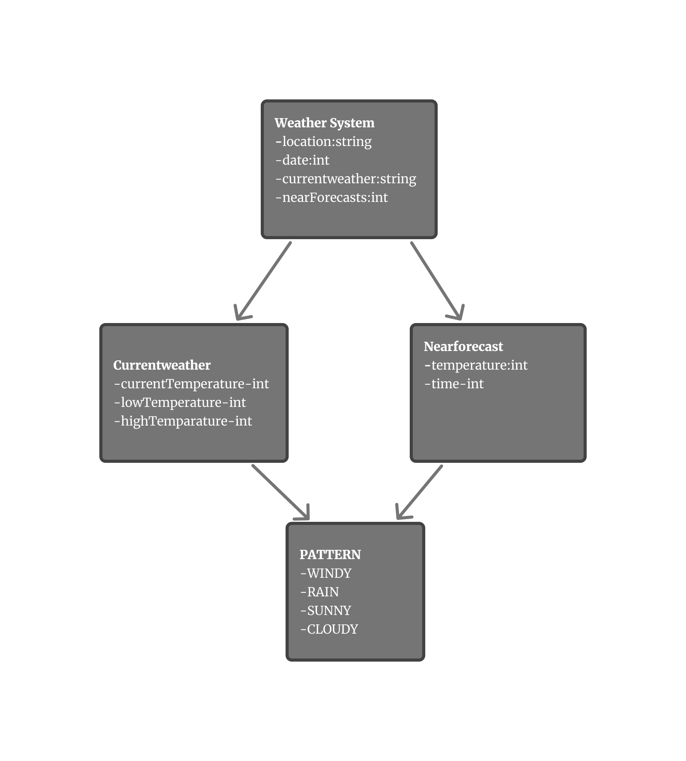

**USE CASE DIAGRAM**

A use case diagram is a visual representation of the functional requirements of a system, illustrating how users interact with the system and the system's responses. For a weather forecasting app, the use case diagram will include actors such as "User," "Weather Data Provider," or "Administrator".

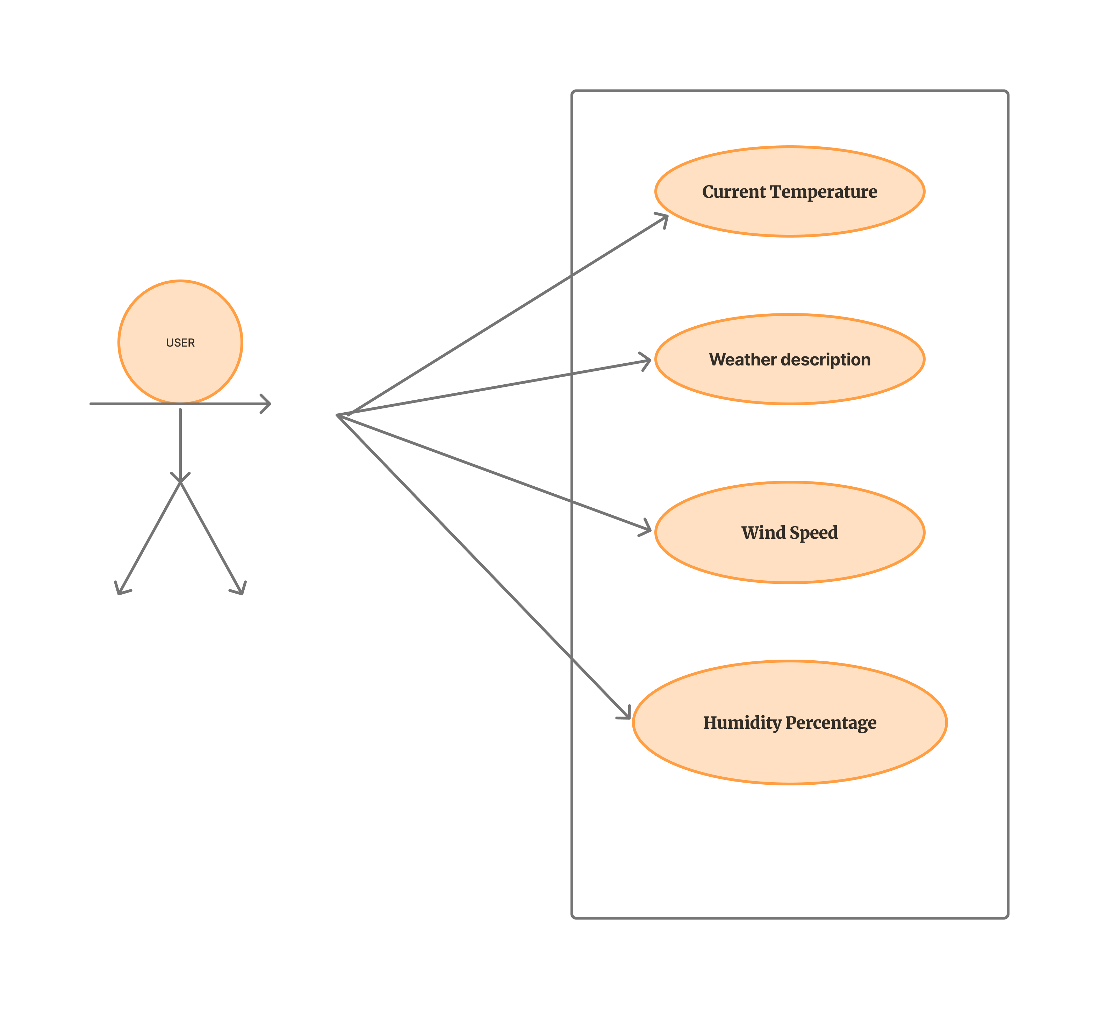

**Description of the Use Case Diagram**:

View Current Weather:

Actor: User

Description: Allows the user to view the current weather conditions for their selected location.

View Hourly Weather Description:

Actor: User

Description: Enables the user to check the weather description for the selected location.

View Daily Forecast:

Actor: User

Description: Permits the user to access the daily weather forecast for the chosen location.

Set Location Preferences:

Actor: User

Description: Allows the user to set and manage location preferences for weather.

Receive Weather Alerts:

Actor: User

Description: Enables the user to receive alerts for severe weather conditions or customized weather events.

ENTITY RELATIONSHIP DIAGRAM

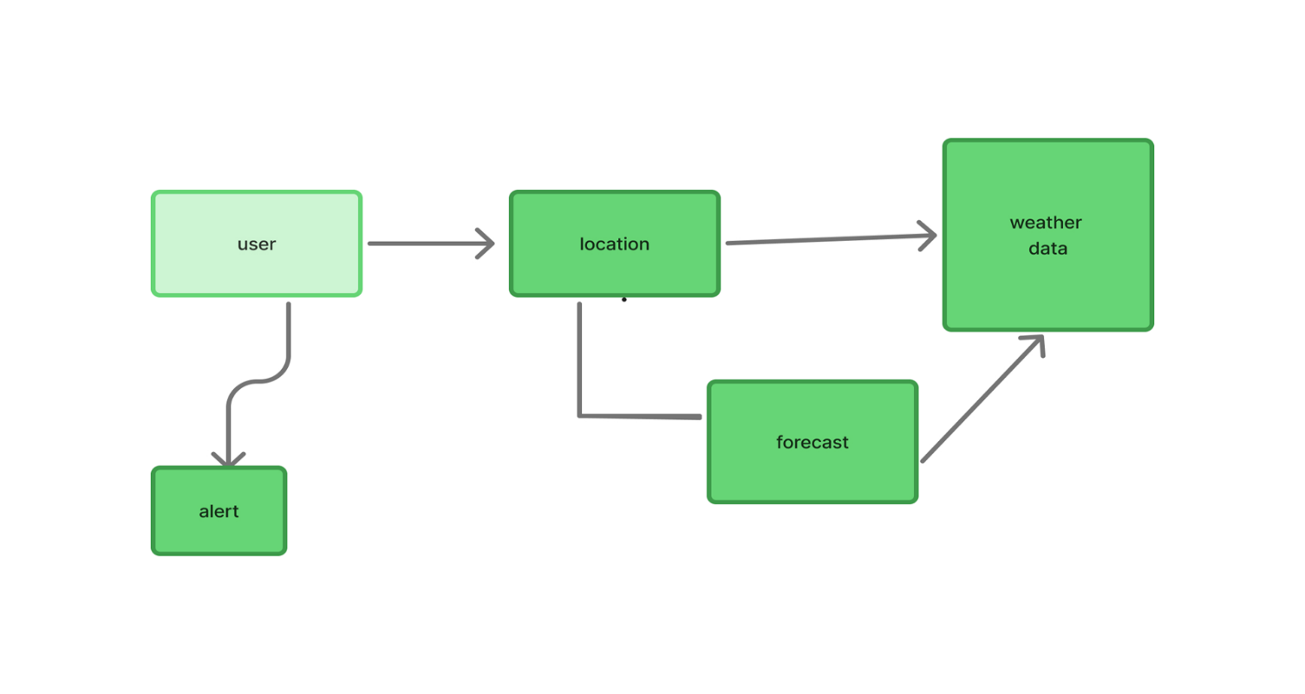

**DATABASE DIAGRAM:**

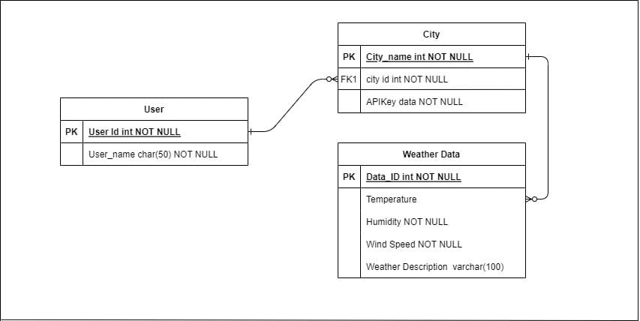

User: Attributes User Id (Primary Key)

City: Attributes : City Name ( Primary Key ) , API Key value.

Weather Details: Attributes: Temperature , Wind Speed , Weather Description , Humidity.

Relation:

Enters: User enters the city name in the application.

Returns: API returns an list of weather details having temperature , wind speed , humidity and weather details

**PHYSICAL DIAGRAM**

*1.USER INTERFACE DIAGRAM*

